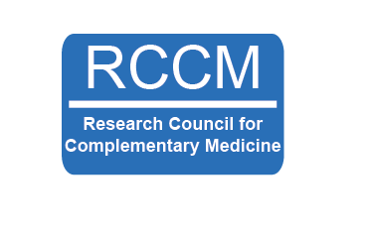
“How to develop research strategy and support research within CAM”
Thursday 21st October 9am -12pm
Online via MS Teams
Includes advice on how to:
Develop a profession-specific research strategy
Effectively manage research issues impacting CAM
Disseminate research insightfully and impactfully to advance your profession

Who should attend?
The event is mainly targeted at those with key roles in CAM professional associations but is also open to CAM researchers and CAM professionals with key roles in governance and CAM practitioners with an interest in research.

Objectives
The event aims to provide participants with information and support to develop strategies for meaningful research in their practice and professional associations.

By the end of the event, participants will:
- Begin to manage the challenge of conducting high quality research in CAM.
- Be able to problem-solve research issues specific to your CAM modality.
- Be aware of the range of research methods that are applicable for CAM studies.
- Know more about potential routes to disseminating research findings in an optimised manner for impactful and insightful change.
- Understand how to use networking to improve research impact.

Sessions will include
- Why do you need a research strategy?
- Talks from RCCM trustees on how they have developed research strategies themselves, and how you can apply this to your work.
- Research methods overview including CAM-specific issues.
- A brief overview of data collection, audits/service evaluation.
- Small group session reflecting on the challenges of research for specific types of CAM.
- Research dissemination and the benefits of planning this early on.
- How professional bodies can link with universities to support research.
- Question and answer sessions with a panel of RCCM trustees.

Speakers
A range of CAM experts will present and lead discussions, including:

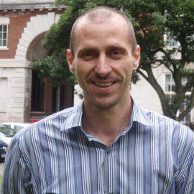
John Hughes PhD, BSc (Hons), Lic. Ac.
Dr John Hughes is the Director of Research for the Royal London Hospital
for Integrated Medicine, UCLH NHS Trust, and Associate Professor in
Integrated Medicine at the University of West London. He is also a member
of the World Health Organization’s Traditional Medicine Reference Group,
and leads the Royal London Hospital for Integrated Medicine WHO
Collaborating Centre.
Dr Carol Granger, DProf MSc MRSB CBiol FBANT
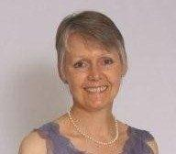
Carol is a registered nutrition practitioner with an honours degree in biochemistry and a Master’s in microbiology. As a Chartered Biologist she had two decades in bioscience research, diagnostics and medical technology before retraining in nutrition. Her doctoral research focused on nutritional therapy practice with people affected by cancer. Carol is also a director of the British Society for Integrative Oncology and contributes to the NIHR research collaboration on nutrition and cancer.
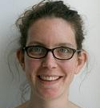
Ava Lorenc, PhD, BSc (Hons)
Ava has been working in CAM research for 15 years. Ava is based at the University of Bristol, working on various research projects including integrated healthcare with a focus on primary care. Ava is also an associate editor for EuJIM and member of the scientific advisory board for the National Centre for Integrative Medicine.

Fee
Tickets for attending the event are:
£50 for non-members
£25 for RCCM members
See https://www.rccm.org.uk/register/full-member/ to become an RCCM member for £50/year.

You can also purchase access to the recording of the event (except the small group sessions) for:
£30 for non-members
£15 for RCCM members

Tickets are available here: https://www.eventbrite.co.uk/e/how-to-develop-research-strategy-and-support-research-within-cam-tickets-170430115062

CPD certificates available on request
For more information
Please email info@rccm.org.uk or see our website https://www.rccm.org.uk/cam-news-and-events/

